Given a List of words, return the words that can be typed using letters of **alphabet** on only one row's of American keyboard like the image below.

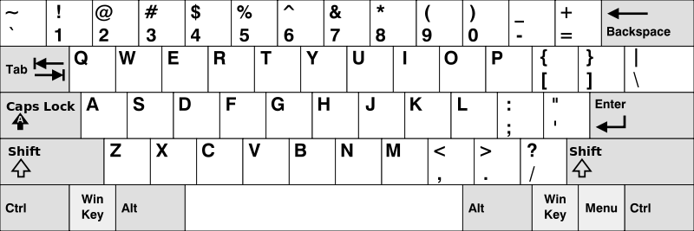

**Example:**

**Input:** ["Hello", "Alaska", "Dad", "Peace"]

**Output:** ["Alaska", "Dad"]

**Note:**

1. You may use one character in the keyboard more than once.
2. You may assume the input string will only contain letters of alphabet.